Assignments on String 1.

Using features of Java 11, read the data from a text file (File name: StudentList.txt). Calculate the count of students and print the names as well as the total count of students on the screen. (If any line in file doesn’t contain a name, for such a record blank space should not be printed in the output) Hint: Use java 11 features of files and String methods to reduce the lines of code to be written.

import java.util.Scanner;  
  
public class String_assignmentQ2 {  
 public static void main(String[] args){  
 Scanner sc = new Scanner(System.*in*);  
 int count =0;  
 int price,total=0;  
 int choice=0;  
 do{  
  
 System.*out*.println("1) INSERT NEW PRICE");  
 System.*out*.println("2) VIEW PURCHASE TOTAL");  
 System.*out*.println("3) EXIT");  
 System.*out*.println("ENTER YOUR CHOICE: ");  
 choice=sc.nextInt();  
 switch (choice){  
 case 1:  
 String s="yes";  
 do{  
 System.*out*.println("Insert" + (count+1) + "price");  
 price = sc.nextInt();  
 total += price;  
 System.*out*.println(" Price has been saved to the file");  
 System.*out*.println("Do you want to enter price for more items?(Yes/No)");  
 s = sc.next();  
 count++;  
 System.*out*.println();  
 }  
 while(s.equalsIgnoreCase("Yes"));  
 break;  
  
 case 2:  
 System.*out*.println("Total price of all items is: " +total);  
 break;  
  
 case 3:  
 System.*exit*(0);  
 default:  
 System.*out*.println("PLEASE ENTER THE CORRECT CHOICE!!!!");  
 }  
 }  
 while(choice !=3);  
 }  
}

Ouput

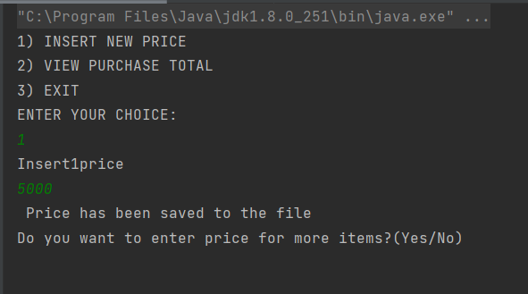

2. Write a program with menu to accept the price of certain items and display their total. When user selects Option 1: should accept the prices of different products and insert these prices into first file (each amount to be inserted in a newline in the file). Next, total of these values should be saved in a new file. Option 2: should allow the user to view the total of these prices from the second file. Sample Output: Select your option (1: Insert New Price, 2: View Purchase Total, 3: Exit) > 1 > Insert 1 st price: > 100 > Price has been saved to the file > Do you want to enter price for more items? (Yes/No) > Yes > Insert 2 nd price: > 200 > Price has been saved to the file > Do you want to enter price for more items? (Yes/No) > No > Select your option (1: Insert New Price, 2: View Purchase Total, 3: Exit) > 2 > Total Price of all items is: 300 > Select your option (1: Insert New Price, 2: View Purchase Total, 3: Exit) > 3 exit program…

import java.io.BufferedReader;  
import java.io.IOException;  
import java.io.InputStreamReader;  
import java.net.HttpURLConnection;  
import java.net.URL;  
import java.net.URLConnection;  
import java.util.List;  
import java.util.Map;  
  
  
public class String_assignmnetQ3 {  
 public static void main(String[] args) throws IOException {  
 try{  
 URL url= new URL("https://httpbin.org/get");  
 HttpURLConnection http= (HttpURLConnection)url.openConnection();  
 URLConnection urlcon = url.openConnection();  
 Map<String , List<String>>header = urlcon.getHeaderFields();  
  
 for(Map.Entry<String , List<String>> mp:header.entrySet())  
 {  
 System.*out*.println(mp.getKey() + ":");  
 System.*out*.println(mp.getValue().toString());  
 }  
 System.*out*.println("Get response header by key ...");  
 List<String> contentLength=header.get("Content-Length");  
 if(contentLength==null){  
 System.*out*.println("Content-Length doesn't present in header");  
 }  
 else{  
 for(String header1: contentLength){  
 System.*out*.println("Content=Length" + header1);  
 }  
 }  
 int statuscode = http.getResponseCode();  
 System.*out*.println("Status Code"+statuscode);  
 System.*out*.println();  
 System.*out*.println("complete source code of the URL is: ");  
  
 BufferedReader br= new BufferedReader(new InputStreamReader(urlcon.getInputStream()));  
 String i;  
 while((i= br.readLine()) != null){  
 System.*out*.println(i);  
 }  
 }  
 catch(Exception e)  
 {  
 System.*out*.println(e);  
 }  
  
 }  
}

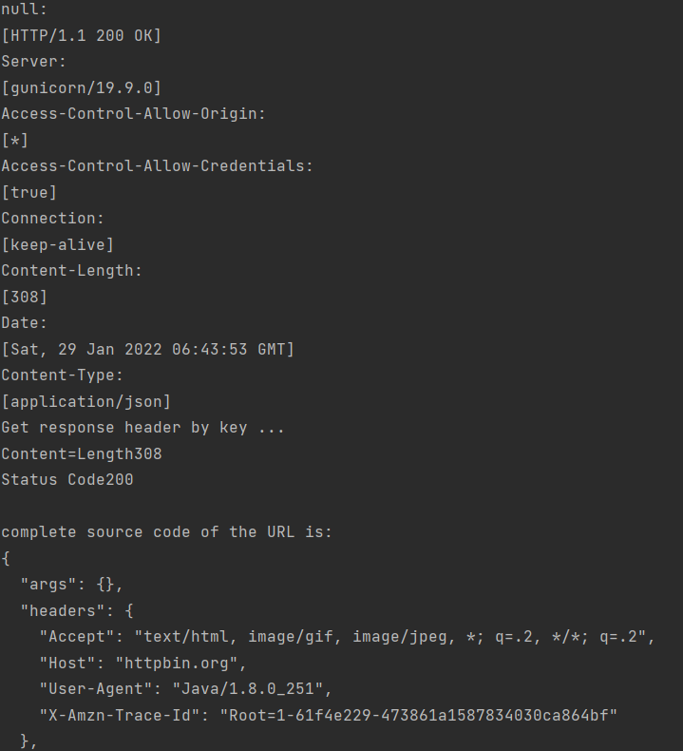

Q3 3. Write a code using HttpClient API which sends a GET request to https://httpbin.org/get, and print out the response header, status code, and body for the given URL. Sample output could be (Note: date and other attribute values may differ in your results): access-control-allow-credentials:[true] access-control-allow-origin:[*] connection:[keep-alive] content-length:[273] content-type:[application/json] date:[Fri, 06 Aug 2021 13:07:41 GMT] server:[gunicorn/19.9.0] 200 { "args": {}, "headers": { "Content-Length": "0", "Host": "httpbin.org", "User-Agent": "Java 11 HttpClient Bot", "X-Amzn-Trace-Id": "Root=1-610d341d-092dc33f698b192a219426d1" }, "origin": "43.255.221.184", "url": "https://httpbin.org/get" }

import java.io.BufferedReader;  
import java.io.IOException;  
import java.io.InputStreamReader;  
import java.net.HttpURLConnection;  
import java.net.URL;  
import java.net.URLConnection;  
import java.util.List;  
import java.util.Map;  
  
  
public class String_assignmnetQ3 {  
 public static void main(String[] args) throws IOException {  
 try{  
 URL url= new URL("https://httpbin.org/get");  
 HttpURLConnection http= (HttpURLConnection)url.openConnection();  
 URLConnection urlcon = url.openConnection();  
 Map<String , List<String>>header = urlcon.getHeaderFields();  
  
 for(Map.Entry<String , List<String>> mp:header.entrySet())  
 {  
 System.*out*.println(mp.getKey() + ":");  
 System.*out*.println(mp.getValue().toString());  
 }  
 System.*out*.println("Get response header by key ...");  
 List<String> contentLength=header.get("Content-Length");  
 if(contentLength==null){  
 System.*out*.println("Content-Length doesn't present in header");  
 }  
 else{  
 for(String header1: contentLength){  
 System.*out*.println("Content=Length" + header1);  
 }  
 }  
 int statuscode = http.getResponseCode();  
 System.*out*.println("Status Code"+statuscode);  
 System.*out*.println();  
 System.*out*.println("complete source code of the URL is: ");  
  
 BufferedReader br= new BufferedReader(new InputStreamReader(urlcon.getInputStream()));  
 String i;  
 while((i= br.readLine()) != null){  
 System.*out*.println(i);  
 }  
 }  
 catch(Exception e)  
 {  
 System.*out*.println(e);  
 }  
  
 }  
}

Output

